DevOps

LAMP Stack 2

# LAMP Stack

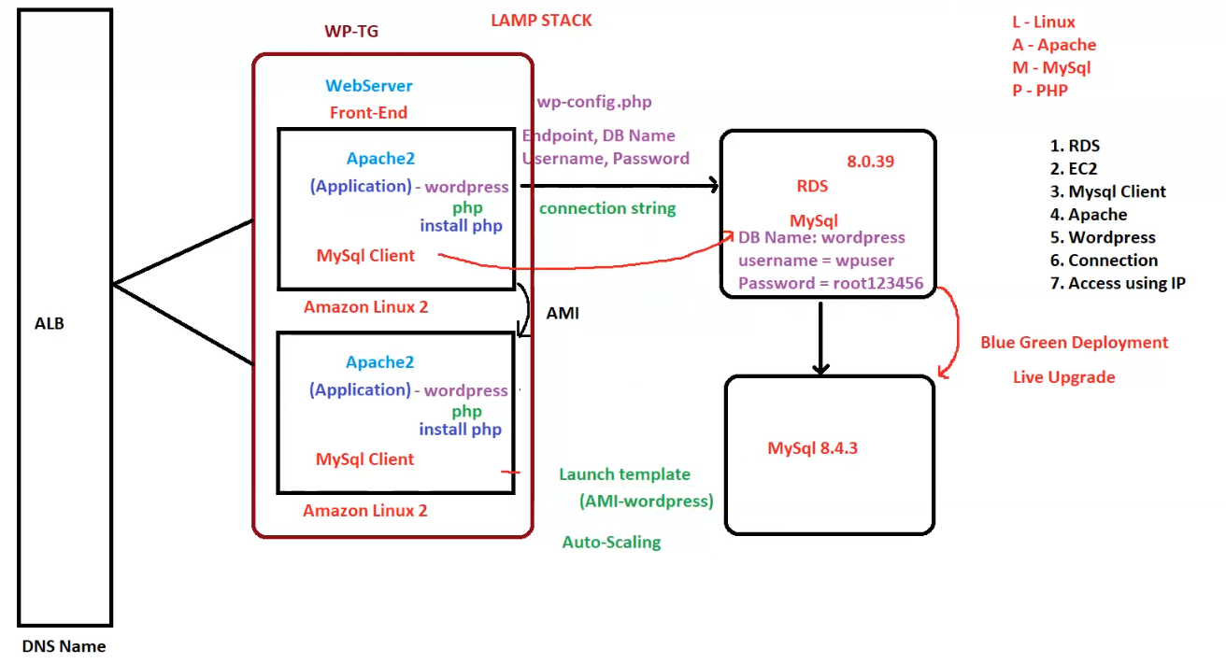

**AWS LAMP Stack with WordPress and RDS**

This architecture represents a **LAMP Stack** deployed on **AWS** using **Auto Scaling, ALB (Application Load Balancer), RDS, and Blue-Green Deployment**.

**1. LAMP Stack Overview**

* **L** - **Linux** (Amazon Linux 2)
* **A** - **Apache** (Web Server)
* **M** - **MySQL** (Database on RDS)
* **P** - **PHP** (Application runtime for WordPress)

**2. Architecture Components**

**A. Application Load Balancer (ALB)**

* **Handles incoming traffic** and distributes it across multiple **EC2 instances**.
* **DNS Name** assigned to ALB for accessing WordPress.

**B. WordPress Web Servers (EC2)**

* **Amazon Linux 2-based instances** running **Apache2, PHP, and MySQL Client**.
* **Auto Scaling**:
  + Uses a **Launch Template** (AMI-wordpress) for deploying new instances.
  + Ensures high availability and scalability.
* **wp-config.php**:
  + Stores **database connection details** (Endpoint, DB Name, Username, Password).
  + Used to connect to the **RDS MySQL database**.

**C. RDS (Amazon Relational Database Service)**

* **Database Engine**: **MySQL 8.0.39** (Upgrading to **8.4.3** via Blue-Green Deployment).
* **DB Name**: wordpress
* **Credentials**:
  + **Username**: wpuser
  + **Password**: root123456
* **Connection String**: Used by WordPress web servers to communicate with the database.

**D. Blue-Green Deployment for MySQL Upgrade**

* **Current version**: **MySQL 8.0.39**.
* **Upgrading to**: **MySQL 8.4.3**.
* **Live Upgrade Process**:
  + **Blue environment**: Existing production database (MySQL 8.0.39).
  + **Green environment**: New version (MySQL 8.4.3).
  + Once the **new version is validated**, traffic is **switched over** with minimal downtime.

**3. Deployment & Scaling**

1. **Auto Scaling** ensures that new EC2 instances are launched when needed.
2. **ALB** distributes traffic across all available instances.
3. **Launch Template (AMI-WordPress)**:
   * Used for launching new EC2 instances **with pre-configured WordPress setup**.
   * Ensures consistency across all servers.

**4. Key Features & Considerations**

✅ **High Availability**: ALB + Auto Scaling ensures uptime.  
✅ **Managed Database**: RDS offloads maintenance, backup, and patching.  
✅ **Security**: Database credentials stored in wp-config.php (should be securely managed).  
✅ **Live Upgrade with Blue-Green Deployment**: Ensures zero-downtime database upgrades.  
✅ **Flexible Access**: WordPress can be accessed using **DNS Name of ALB**.

**5. Steps for Deployment**

1. **Provision RDS MySQL Instance** with database wordpress.
2. **Launch EC2 Instances** (Web Servers) with **Apache, PHP, and MySQL Client**.
3. **Deploy WordPress** and configure wp-config.php with RDS credentials.
4. **Set up ALB** and configure Auto Scaling.
5. **Perform Blue-Green Deployment** to upgrade MySQL from **8.0.39 to 8.4.3**.

**Conclusion**

This AWS architecture leverages **Auto Scaling, ALB, and RDS** to create a **scalable, highly available WordPress deployment** with **zero-downtime upgrades** using **Blue-Green Deployment**.